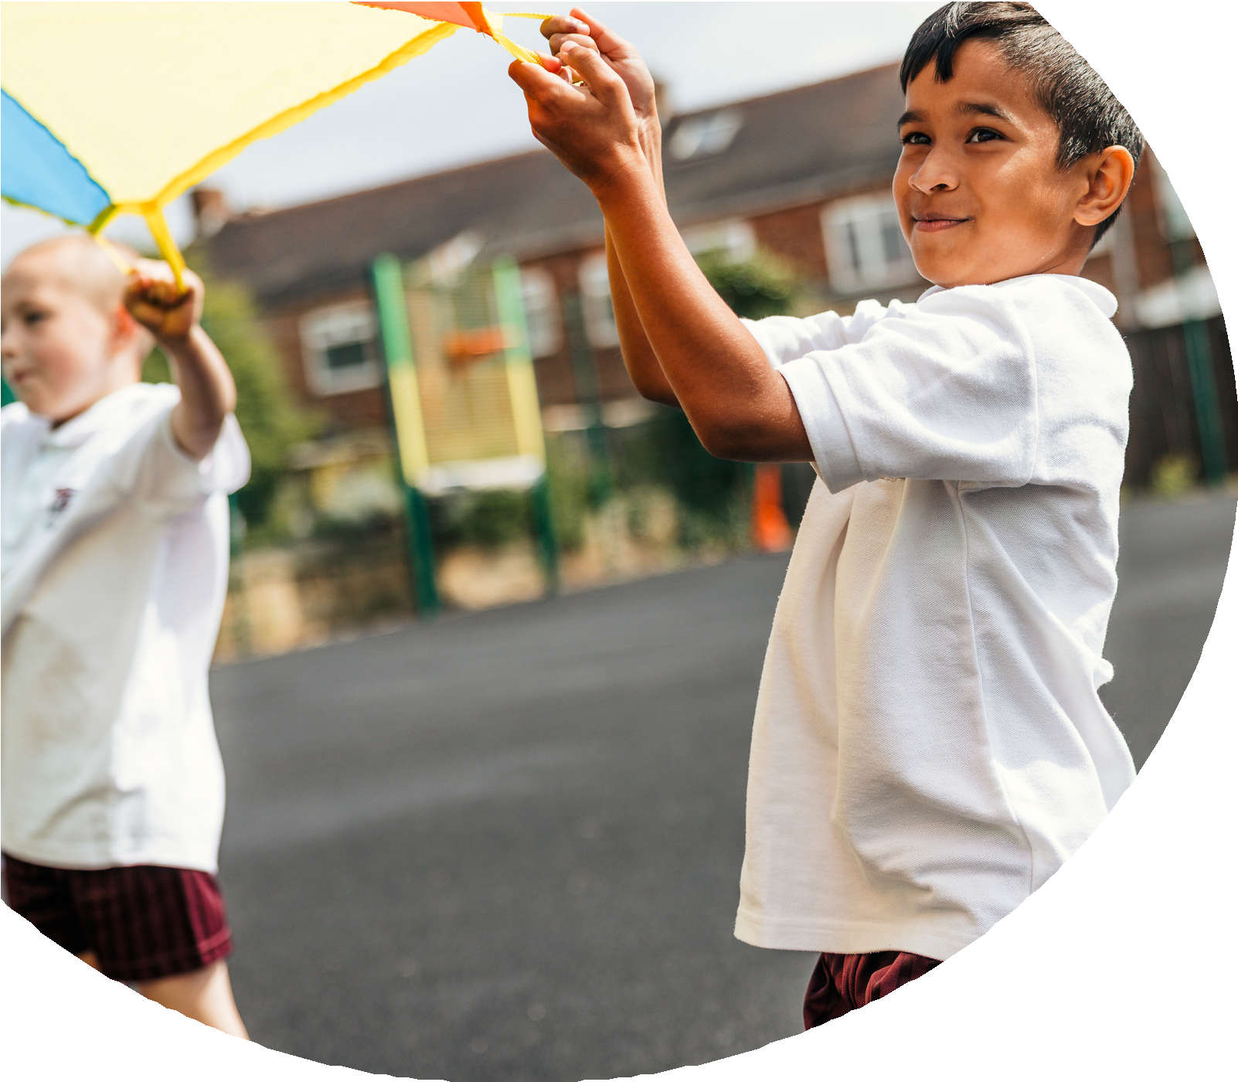
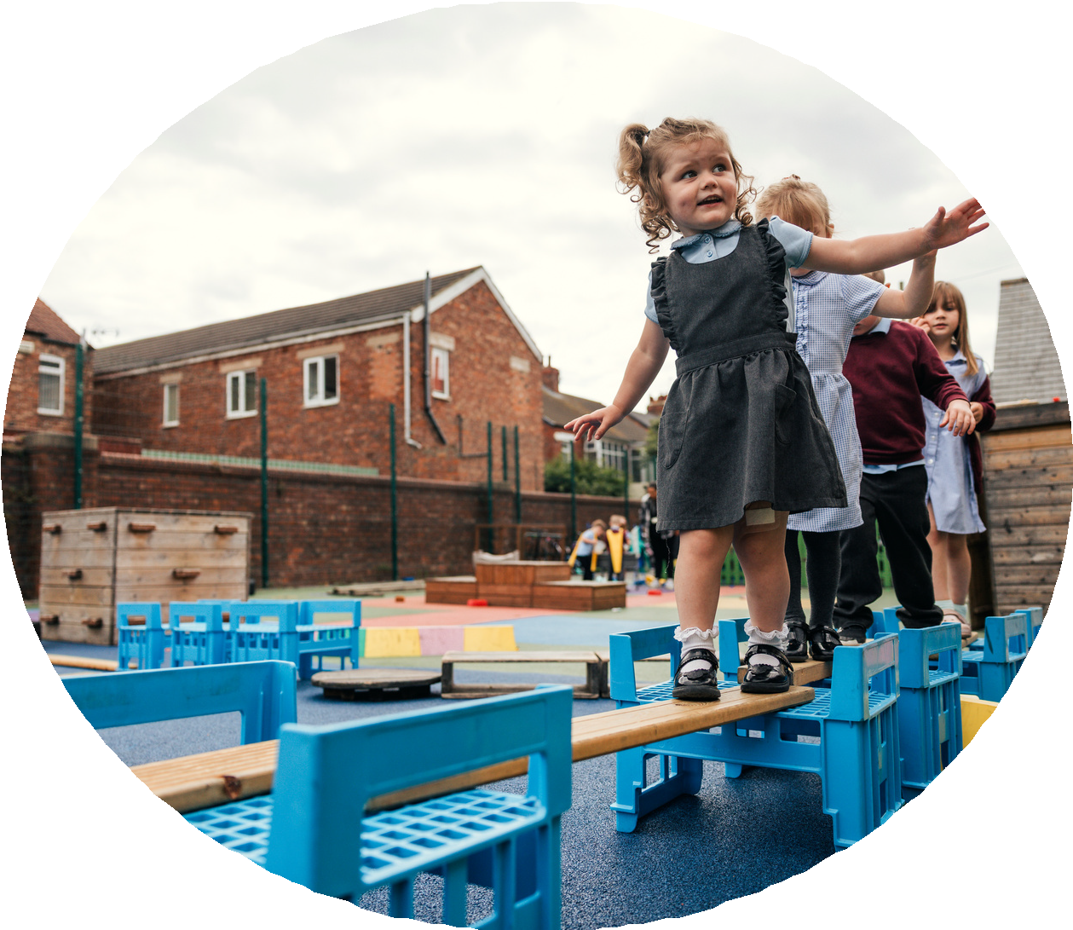

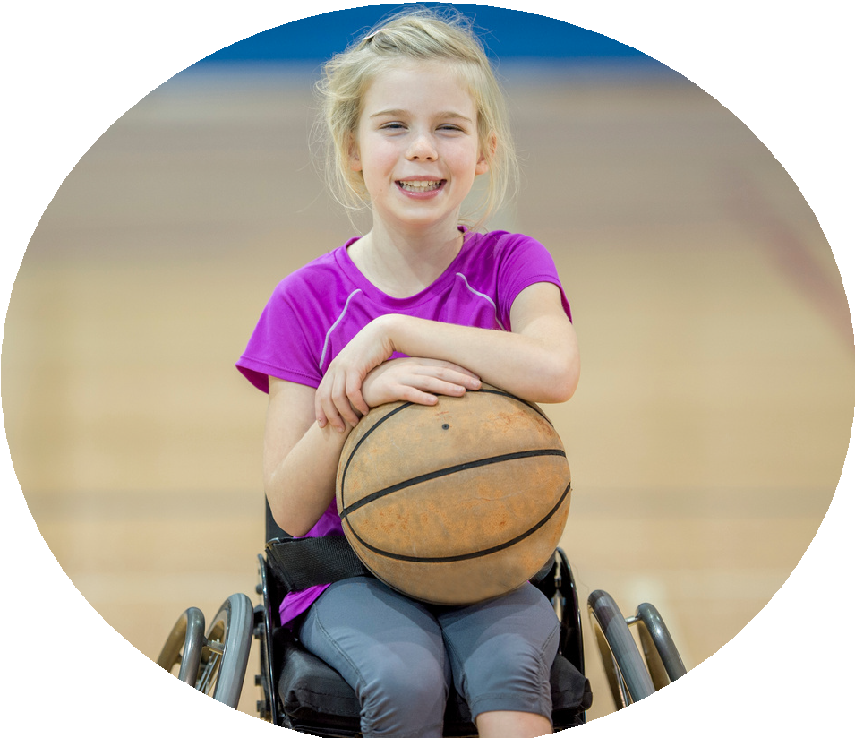



PE and sport premium monitoring and tracking form 2025/2026

Commissioned by


Review of the last academic year (2024/2025)

Swimming and Water Safety | What went well? Supporting evidence? | What didn't go well? Supporting evidence?
1. Swim competently, confidently and proficiently over a distance of at least 25 metres | 55% of children were able to competently swim 25 metres. Evidence shown in the data. | Children are still struggling to master the art of swimming so we have currently implemented that 3-year groups will go swimming and we have On Land training
2. Use a range of strokes effectively (for example, front crawl, backstroke and breaststroke) | 55% of children were able to competently swim 25 metres. Evidence shown in the data. | Children aren’t confident at swimming therefore haven’t progressed with different strokes.
3. Perform safe self-rescue in different water-based situations | Year 6 were able to safe self-rescue all children accessed these lessons. | We are implementing that all children in school will be accessing On Land Training therefore, they will be competent and confident by Year 6.
- Take some time to reflect on your intent, implementation and impact from last academic year to celebrate your wins but to also think about improvements for the year ahead.
- You do not need to complete every box. Just record the information that is key to your school's priorities and areas of focus.
Remember - Be clear about how you focussed spending on key groups such as SEND, girls and disadvantaged pupils.

Review of the last academic year (2024/2025)
Key areas as outlined in PE and sport premium guidance | What went well? Supporting evidence? | What didn't go well? Supporting evidence?
1. Increasing confidence, knowledge and skills of all staff in teaching PE and sporting activities prioritising CPD and training where needed | 1. Teachers are more confident in teaching PE and effective teaching.  2. Get Set for PE has been in place for three terms and is used effectively to create the high-quality lessons. With support, teachers adapt the scheme to suit the needs of their children Using Get set 4 PE provides teachers with key vocabulary and planning with progression. Using pre-planned planning helps staff to understand the progression of skills and vocabulary.  3.Increase PE leaders CPD to support and drive the PE curriculum, through AFPE affiliation and subscription to Dance Desk  3. WGA SSP Membership  We have signed up to Woodgreen Academy Sport Memberships to provide CPD to supports coach and PE lead. | Teaching Gymnastics- teachers believe that they need some more CPD in Gymnastics.
2. Increasing engagement of all pupils in regular physical activity and sporting activities | Children are now more active throughout the day, and this has been seen at lunchtime.  The children are engaged in sports clubs and 90% of our children are active during lunchtimes.  100% of KS2 children have had the options of accessing a club before or afterschool club.  Children are engaging with support during lunch times and break times. Children are having positive experiences outside of PE.  Children understand the importance of living a healthy lifestyle and how they can do this in different ways. This is now sustainable because we have the equipment and we’ve now got a set routine of activities for the children. | More children in KS1 to participate in an afterschool club.
3. Raising the profile of PE and sport across the school, to support whole school improvement | This year we’ve implemented a range of ways to get our less active children active. We’ve implemented a before school club and lunchtime clubs which target children that aren’t active throughout the day. This is delivered by a coach who is familiar with the children, therefore, is able to tailor the group to allow the best outcome. We have after school clubs which allow children to access additional time to practice skills and enjoy sports outside of the school day.  Using CPD and additional resources we’ve adopted a curriculum that allows the children to access a tailor curriculum. | Continue to promote PE and ensure that it is supporting our less active children so that we are working towards healthier children.
4. Offer broader and more equal experience of a range of sports and physical activities to all pupils and ensure equal access to sport for boys and girls | We have adapted our provision for a group of children within in school with additional needs so that they are able to access a progressive and challenging curriculum that meets their needs. | We want more children to access clubs outside of school. The focus for 2025-2026- will be girls.
5. Increasing participation in competitive sport | More children have participated in competitive sports within the community. All children have participated in a competition within school. As a school we made connections with other schools in our local area, allowing us to continue with additions competitive sports.  Children have been accessing more competitive competitions, allowing them to build on their resilience, perseverance and much more.  WGA- It provided our children with enriched opportunities to participate in competitive sports within their local community. | We want a larger portion of children to access competitions in the community.

Aims for the next academic year (2025/2026)
- Using your whole school priorities, school development plan and previous PE, school sport and physical activity data, set out your aims for the year ahead.
- Think about specific areas of need such as inactive girls, SEND and disadvantaged pupils
- Remember to also input your swimming data and reflections in the table located at the bottom of this page.
- Consider which of the 5 key areas improvements will be focussing on:
- Increasing confidence, knowledge and skills of all staff in teaching PE and sporting activities prioritising CPD and training where needed.
- Increasing engagement of all pupils in regular physical activity and sporting activities
- Raising the profile of PE and sport across the school, to support whole school improvement
- Offer a broader and more equal experience of a range of sports and physical activities to all pupils and ensure equal access to sport for boys and girls
- Increasing participation in competitive sport

Swimming and Water Safety | Input data | Reflections
1. Swim competently, confidently and proficiently over a distance
of at least 25 metres
2. Use a range of strokes effectively
(for example, front crawl, backstroke and breaststroke)
3. Perform safe self-rescue in different water-based situations

Aim | Why? | Key area | Supporting evidence
We are going to support teachers in planning, delievering gymnastic lessons. They will be confident and be able to apply their skills and knowledge. | Teachers didn’t feel confident in delivering Gymnastic lessons and asked for CPD to deliver effective lessons | To increase all staff’s confidence, knowledge and skills in teaching PE and sport
To raise the profile of swimming and the amount of children who can perfom safe self-resuce in different water- based sitations. | We want children to be able to confidently and competently be able to safe rescue. | Swimming and Water Safety.  To understand the importance of water safety and when they might need to use it.
We are focusing on children living active lifestyles. Getting children to understand the importance of living active lifestyles.  To promote and support children understand living active lifestyle. They will understand the importance. | At St Matthew’s we want the children to understand why it is important and get children to understand the need to live active lifestyles especially regarding our demographics.  We will be completing activities around the world cup | To get all children to understand healthy life styles and why are they are important.  To understand how to live a healthy life.
Aims for the next academic year (2025/2026)

Plan, monitor and evaluate (2025/2026)

Your Objective:
Increase participation in competitive sports

 | Intent – what is your objective? | Implementation - How will you achieve this? | Impact - What do you hope to see? | Supporting evidence
Plan and monitor | Children to compete in the in more competitive sports.  We want children to participate in at least one competitive sport.  We want children to have chance to broaden their physical experiences. | Work with Woodgreen Academy to increase the number of opportunities children get. Select different children for the different events so the least active children get a chance at trying new sports. | Children who are inspired by different sports and children understanding that some sports are competitive. To have more resilient children. | Pupil voice  Children engagement  Registers.
 | What impact have you seen? | Are the improvements sustainable? How? | Supporting evidence | Approx. cost
Evaluate

 | Intent – what is your objective? | Implementation - How will you achieve this? | Impact - What do you hope to see? | Supporting evidence
Plan and monitor | To promote children living active lifestyles.  For children to fully understand why it’s important to live healthy lifestyles.  Enrich Education- orienteering package- | We will be promoting different sports.  - Football through the world cup.  - Activities around London Marathon/ Daily Mile.  - Lessons linked to science on why it’s important to live active life.  We will be having CPD and an orienteering package | Children will participate in more clubs so we will have a bigger up take in the club.  More children will participate in different activities at Lunch time.  Children will understand the importance of being active.  Children will be more active and see how PE can be taught throughout different subject. | - Club registers.  - Observations at lunch time.
 | What impact have you seen? | Are the improvements sustainable? How? | Supporting evidence | Approx. cost
Evaluate
Your Objective:
Increasing engagement of all pupils in regular physical activity and sport
Your Objective:
increasing all staff’s confidence, knowledge and skills in teaching PE and sport

 | Intent – what is your objective? | Implementation - How will you achieve this? | Impact - What do you hope to see? | Supporting evidence
Plan and monitor | To improve Gymnastic at St Matthew’s.  We are going to support teachers in planning, delievering gymnastic lessons. They will be confident and be able to apply their skills and knowledge. | All teaching staff completed a Gymnastic CPD. The CPD was in line with AFPE guidelines  Staff will be supported with team teach lessons with PE lead or sports coach. | We expect to see staff to improve their practice and see this in lessons.  Staff will be able plan and deliver progressive lessons alongside using Get set 4 PE. | Staff Voice through questionnaires  Lesson Observations
 | What impact have you seen? | Are the improvements sustainable? How? | Supporting evidence | Approx. cost
Evaluate | 89% of teacher feel confident or very confident to teach Gymnastics after the CPD training. Where before the training only 22% of staff felt confident in teaching PE. | These improvements are sustainable as teacher will be teaching Gymnastics yearly, so they are able use their skills. | See appendix 1  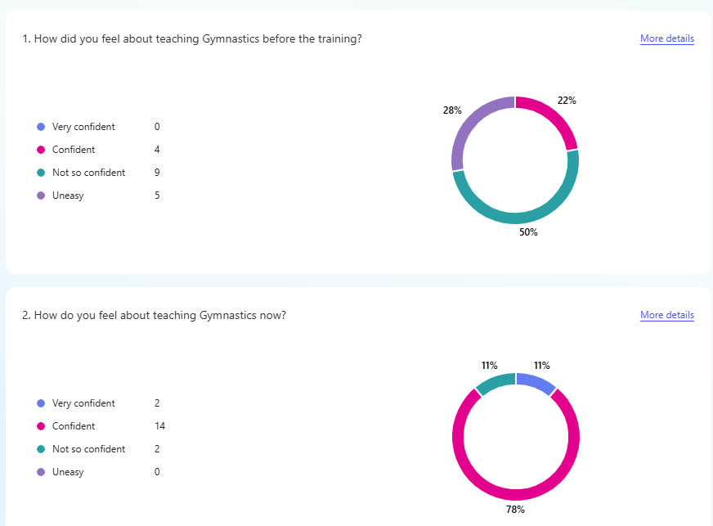 | CPD cost- £331.00

Your Objective:  Increasing engagement of all pupils in regular physical activity and sport | Intent – what is your objective? | Implementation - How will you achieve this? | Impact - What do you hope to see? | Supporting evidence
Plan and monitor | To ensure all children can access a diverse curriculum. With an increase of children with a diverse SEND need.  Gifted and Talented children. We are going to support our gifted and talented gymnast by providing them with an opportunity to go to the Gymnastic Festival at Earls Gymnastic Centre.  To close the gap of children who have weak fundamental skills.  Provide specialist support to help children with additional needs to access and participate fully in PE lessons | We will get adapted equipment to adapt lessons.  Providing 10 KS2 and 10 KS1 an opportunity to participate in the Gymnastic Festival.  Provide an after-school club which specialising in improving their fundamental skills. | Children engaging with PE lessons.  We hope that this will allow them the opportunity to see gymnastics outside of school. | PE learning walks  Pupil voice/ evidence taken for their EHCP’s.  Student voice
 | What impact have you seen? | Are the improvements sustainable? How? | Supporting evidence | Approx. cost
Evaluate

Your Objective: Swimming-
To increase the amount of children swimming by then of Year 6
 | Intent – what is your objective? | Implementation - How will you achieve this? | Impact - What do you hope to see? | Supporting evidence
Plan and monitor | To get at least 60/65% of children swimming in Year 6. We are seeing low numbers of children who can swim by the end of Year 5. Therefore, we are having additional swimming for those children who couldn’t swim by the end of Year 5. | Children will get additional swimming lessons. (once a week)  on Land training lessons. | More children being able to swim at the end of the year. | Data
 | What impact have you seen? | Are the improvements sustainable? How? | Supporting evidence | Approx. cost
Evaluate

This page has been left blank for any notes or supporting information.

Appendix 1- data from gymnastic CPD.



