Autumn 1 | Autumn 2 | Spring 1 | Spring 2 | Summer 1 | Summer 2
Purpose: n/a | Purpose: n/a | Purpose: to write sequenced sentences to form a short narrative. | Purpose: to write sequenced sentences to form a short narrative. | Purpose: to write sequenced sentences to form a short narrative. | Purpose: to describe Zog
 |  | 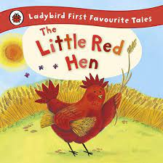 |  |  | 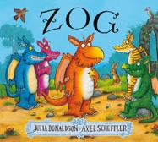
Read Write Inc. | Read Write Inc. | Little Red Hen | Dogger | Jack and the Beanstalk | Zog
Outcome: n/a | Outcome: n/a | Outcome: sequenced sentences about the story, ‘Little Red Hen’. | Outcome: sequenced sentences about the story, ‘Dogger’. | Outcome: sequenced sentences about the story, ‘Jack and the Beanstalk’. | Outcome: sentences about Zog.
 |  | Writing Features:  Past tense: regular verbs where ed is added as a suffix).  Third person (Little Red Hen picked the corn)  Regular plural noun suffixes –s or –es [for example, dog, dogs; wish, wishes], including the effects of these suffixes on the meaning of the noun.  Suffixes that can be added to verbs where no change is needed in the spelling of root words (e.g. helping, helped, helper).  Joining words and joining clauses using and.  Separation of words with spaces. | Writing Features:  Past tense: regular verbs where ed is added as a suffix).  Third person (Dave washed Dogger in a bowl; Bella joined in to look for Dogger and they searched together)  Regular plural noun suffixes –s or –es [for example, dog, dogs; wish, wishes], including the effects of these suffixes on the meaning of the noun.  Suffixes that can be added to verbs where no change is needed in the spelling of root words (e.g. helping, helped, helper).  Joining words and joining clauses using and.  Separation of words with spaces. | Writing Features:  Past tense: regular verbs where ed is added as a suffix).  Third person (Jack planted the bean)  Regular plural noun suffixes –s or –es [for example, dog, dogs; wish, wishes], including the effects of these suffixes on the meaning of the noun.  Suffixes that can be added to verbs where no change is needed in the spelling of root words (e.g. helping, helped, helper).  Joining words and joining clauses using and.  Separation of words with spaces. | Writing Features:  Past tense: regular verbs where ed is added as a suffix).  Third person (Jack planted the bean)  Regular plural noun suffixes –s or –es [for example, dog, dogs; wish, wishes], including the effects of these suffixes on the meaning of the noun.  Suffixes that can be added to verbs where no change is needed in the spelling of root words (e.g. helping, helped, helper).  Joining words and joining clauses using and.  Separation of words with spaces.
Purpose: to write about the trip. | Purpose: n/a | Purpose: to write about a person and myself | Purpose: to write sequenced sentences to form a short narrative. | Purpose: to learn a poem | Purpose: to sequence sentences to form a short narrative.
 |  |  |  | 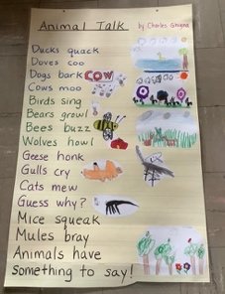 | 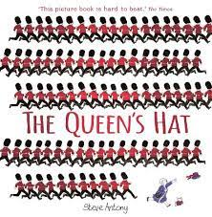
Trip to the Black Country Museum |  | Mae Jemison | Kipper’s Birthday | Animal Talk by Charles Ghigna | The Queen’s Hat
Outcome: a sequence of sentences about the trip. | Outcome: n/a | Outcome: sentences about Mae Jemison and myself | Outcome: sequenced sentences about making a cake | (not to be written, only said/ recited/ performed) | Outcome: sequenced sentences about the story, ‘The Queen’s Hat’.
 |  | Writing Features:  Present tense (to be (is, am, are) to have (have has), regular verbs where s is added for it, he, she).  First and Third person (She wears a spacesuit and I wear school clothes)  Capital letters for names and for the personal pronoun I.  Introduction to capital letters, full stops, question marks and exclamation marks to demarcate sentences.  Regular plural noun suffixes –s or –es [for example, dog, dogs; wish, wishes], including the effects of these suffixes on the meaning of the noun .  Suffixes that can be added to verbs where no change is needed in the spelling of root words (e.g. helping, helped, helper)  Joining words and joining clauses using and  Separation of words with spaces | Writing Features:  Present tense (to be (is, am, are) to have (have has), regular verbs where s is added for it, he, she)  Third person (break the eggs and mix them with the flour)  Regular plural noun suffixes –s or –es [for example, dog, dogs; wish, wishes], including the effects of these suffixes on the meaning of the noun .  Suffixes that can be added to verbs where no change is needed in the spelling of root words (e.g. helping, helped, helper)  Joining words and joining clauses using and  Separation of words with spaces  words with spaces |  | Writing Features:  Past tense: regular verbs where ed is added as a suffix).  Third person (the wind blew the hat and it soared over the queen)  Regular plural noun suffixes –s or –es [for example, dog, dogs; wish, wishes], including the effects of these suffixes on the meaning of the noun.  Suffixes that can be added to verbs where no change is needed in the spelling of root words (e.g. helping, helped, helper).  Joining words and joining clauses using and.
 |  | Purpose: to write about a reptile | Purpose: to write a sequence of sentences.
 |  | 
 |  | Reptiles | Kipper’s Birthday
 |  | Outcome: sentences about reptiles. | Outcome: sequenced sentences about having a party
 |  | Writing Features:  Present tense (to be (is, am, are) to have (have has), regular verbs where s is added for it, he, she)  Third person (It has 4 legs)  Regular plural noun suffixes –s or –es [for example, dog, dogs; wish, wishes], including the effects of these suffixes on the meaning of the noun .  Suffixes that can be added to verbs where no change is needed in the spelling of root words (e.g. helping, helped, helper)  Joining words and joining clauses using and  Separation of words with spaces | Writing Features:  Present tense (to be (is, am, are) to have (have has), regular verbs where s is added for it, he, she)  Third person (break the eggs and mix them with the flour)  Regular plural noun suffixes –s or –es [for example, dog, dogs; wish, wishes], including the effects of these suffixes on the meaning of the noun .  Suffixes that can be added to verbs where no change is needed in the spelling of root words (e.g. helping, helped, helper)  Joining words and joining clauses using and  Separation of words with spaces

