Autumn 1 | Autumn 2 | Spring 1 | Spring 2 | Summer 1 | Summer 2
Purpose: to describe | Purpose: to report | Purpose: to describe | Purpose: to explain | Purpose: to describe | Purpose: to report/inform
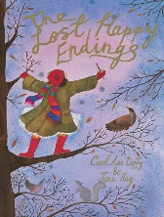 | 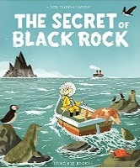 | 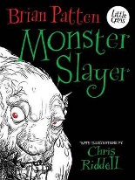 | 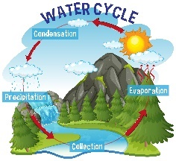 | 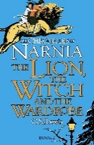 | 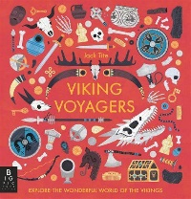
The Lost Happy Endings | The Secret of Black Rock | Monster Slayer | The Water Cycle | The Lion, The Witch and the Wardrobe | Viking Warriors
Outcome: a character description of Jub. | Outcome: a newspaper report on the incident at Black Rock. | Outcome: a character description of Grendel. | Outcome: an explanation of the water cycle. | Outcome: a setting description of the White Witch’s castle. | Outcome: a non-chronological report on the Vikings.
Text Features:  - Title  - Opening sentence to introduce the character.  - Clearly, organised paragraphs (physical appearance, actions and behaviours, personality, what others think and feel about them).  Language Features:  Tense: Present  Person: 3rd  Formality: Formal  - Expanded noun phrases  - Powerful verbs and adverbs  - Similes and metaphors  - Show not tell  - Precise and ambitious vocabulary  - Fronted adverbials  - Prepositional phrases  - Apostrophes for possession | Text Features:  - Headline  - Byline  - Date  - Introduction (What happened, where, when, who to)  - Main Body Paragraph (how and why it happened)  - Factual Information  - Opinions (quotes)  - Closing (What has happened since the event).  Language Features:  Tense: Present and Past  Person: 3rd  Formality: Formal  - Adverbials of time to order events  - Cause and effect  - paragraphs. | Text Features:  - Title  - Introduction (to the character)  - Organised paragraphs (appearance, personality, actions/behavior, effect on others.  Language Features:  Tense: Present  Person: 3rd  Formality: Formal  - Expanded noun phrases  - Powerful verbs and adverbs  - Similes and metaphors  - Show not tell  - Precise and ambitious vocabulary  - Fronted adverbials  - Prepositional phrases  - Apostrophes for possession | Text Features:  - Title  - Introduction  - Logical, chronological order  - Paragraphs for each step or stage  Conclusion  Language Features:  Tense: Present  Person: 3rd  Formality: Impersonal/Formal Tone  - Technical vocabulary  - Time and sequencing adverbials/conjunctions  - Causal language  - Diagrams and Labels | Text Features:  - Title  - Introduction to the setting  - Paragraphs  - Chronological movement through setting.  Language Features:  Tense: Present  Person: 3rd  Formality: Formal  - Powerful adjectives and expanded noun phrases  - Figurative language (similes, metaphors, alliteration and personification)  - Sensory detail  - Precise verbs  - Varied sentence starters (adverbials, conjunctions)  - Mood and Atmosphere  - Apostrophes for possession | Text Features:  - Title  - Subheadings  - Factual information  - Introduction  - Paragraphs around a theme  - Fact boxes or bullet points  - Images, diagrams captions.  Language Features:  Tense: Present  Person: 3rd  Formality: Formal  - General nouns  - Technical Vocabulary  - Cause and effect (to explain ideas)  - Formal tone  - Descriptive but factual language  - Use of facts/statistics
Purpose: to entertain | Purpose: to persuade | Purpose: to entertain | Purpose: to recount | Purpose: to entertain | Purpose: to perform
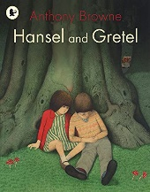 | 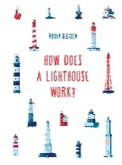 |  |  |  | Poetry and Plays
Hansel and Gretel | How Does a Lighthouse Work? | Monster Slayer | The Lion, The Witch and the Wardrobe | The Lion, The Witch and the Wardrobe
Outcome: A fairy-tale narrative about children who escape from a witch. | Outcome: A persuasive Letter to the mayor in favour of building a lighthouse on Black Rock. | Outcome: A legend: the third part of the Beowulf story – his fight against the dragon. | Outcome: a diary entry as Lucy recounting her first trip into Narnia. | Outcome: a fantasy narrative about a child saving a fantasy world from evil. | Outcome: a fantasy narrative.
Text Features:  - Title  - Clear narrative structure: Opening (Once upon a time...), build-up, problem, resolution, ending (they lived happily ever after)  - Setting (an imaginary or enchanted world)  - Characters with clear roles (good, evil, magical helper(s)), sometimes royalty or creatures)  - Magic or enchantment  - Moral or lesson  - Dialogue  - Paragraphing  Language Features:  Tense: Past  Person: 3rd  Formality: Formal  - Timeless openers and closers  - Descriptive noun phrases  - Powerful verbs and adverbs  - Fronted adverbials  - Speech/dialogue  - Figurative language (similes, personification)  - Repetition for effect (huffed and puffed, mirror, mirror) | Text Features  - Date  - Salutation  - Introductory paragraph (why you are writing)  - Main body paragraphs (reasons)  - Persuasive features (exaggeration, rhetorical questions, repetition)  Language Features:  Tense: Present  Person: 3rd  Formality: Very Formal  - Persuasive/ appealing adjectives | Text Features:  - Title  - Clear narrative structure (opening, build-up, problem/ climax, resolution, ending)  - Timeless setting  - Heroic or significant character (Beowulf)  - Elements of the supernatural or mythical.  - Paragraphs for structure (new speaker new line)  - Moral or Lesson  - Paragraphing  Language Features:  Tense: Past  Person: 3rd  Formality: Formal except dialogue.  - Descriptive language (Expanded noun phrases)  - Powerful verbs and adverbs.  - Figurative language (similes, metaphors, personification)  - Fronted adverbials.  - Speech punctuation.  - Alliteration or repetition for effect. | Text Features:  - Clear Opening (date, time, context, salutation)  - Clear closing (concluding thought)  - Chronological structure  - Paragraphing  - Dates/times  Language Features:  Tense: Past  Person: 1st  Formality: Informal tone (contractions)  - Personal voice and emotive language  - Time and place adverbials and conjunctions  - Descriptive detail  - Reflective sentences | Text Features:  - Title  - Clear narrative structure (opening, build-up, problem/climax, resolution, ending)  - Imaginative setting  - Heroic or curious character  - Elements of the magic or impossible.  Paragraphs for structure (new speaker new line)  Language Features:  Tense: Past  Person: 3rd  Formality: Formal except dialogue.  - Expanded noun phrases  - Descriptive language  - Figurative language (similes, metaphors, personification)  - Powerful verbs and adverbs.  - Fronted adverbials.  - Speech punctuation. | Performance Features  What a Shame You Lost Your Tail (John Agard)  The Tree and the Pool (Brian Patten)  Lesser Known, But Not Less Important (AF Harold)  You Can’t Stop Me! (Miriam Moss)

