Autumn 1 | Autumn 2 | Spring 1 | Spring 2 | Summer 1 | Summer 2
Purpose: to describe | Purpose: to recount | Purpose: to describe | Purpose: to describe | Purpose: to describe | Purpose: to report/inform
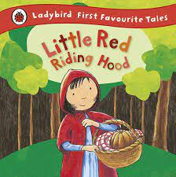 | 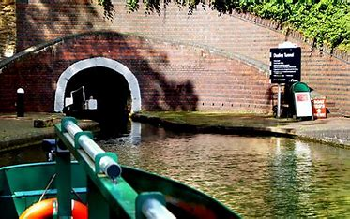 | 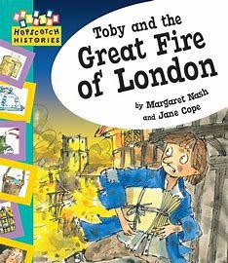 | 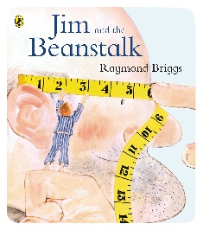 | 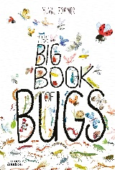 | 
Little Red Riding Hood | Trip to Dudley Canal and Caverns | Toby and the Great Fire of London | Jim and the Beanstalk | The Big Book of Bugs | Paddington
Outcome: a character description | Outcome: a recount about the trip to Dudley Canal and Caverns | Outcome: a setting description of London on fire. | Outcome: a character description | Outcome: a non-chronological report on an insect. | Outcome: a persuasive letter
Text Features:  Title: Simple: “Little Red Riding Hood” or “About Little Red Riding Hood”  Opening sentence: Introduces who is being described:  “Little Red Riding Hood is a kind and brave girl who lives near the woods.”  Paragraph focus:  One paragraph about her appearance; another about what she does and what she is like.  Description of appearance and personality/actions: Appearance: “She wears a bright red cloak and shiny black shoes.” Personality/ actions: “She is helpful and loves to visit her grandma.”  Ending: May sum up why she is special or what you like about her: “That is why she is so loved by everyone in the story.”  Language Features:  Tense: Past  Person: 3rd  Formality: informal, friendly tone (like telling a friend or writing for a class book).  Adjectives and expanded  noun phrases: “Her bright red cloak,” “long brown hair,” “kind, gentle face.”  Subordination (because, when, if, that, so that) to explain more: “She wears her red cloak so that people know who she is.”  “She is brave because she goes into the dark woods alone.”  Simple and compound sentences  - “She is kind and helpful.”  - “She likes picking flowers but sometimes she forgets to hurry.”  Time or sequencing words (optional, if describing what she does): “Sometimes,” “Often,” “Usually.”  Emotive or evaluative language: “She is very sweet,” “Everyone loves her,” “She is clever and brave.”  Rhetorical question (if modelled and appropriate): “Who wouldn’t feel safe with her around?” | Text Features:  Title: Clear and simple: “Our Trip to Dudley Canal and Caverns”  Introduction: Who went, where, and when:  “On Monday, Year 2 went on an exciting trip to Dudley Canal and Caverns.”  Chronological order: Events described in the order they happened: travelling there → boat ride → exploring the caverns → coming back.  Paragraphs grouped around a theme or event: One paragraph about the journey, another about what was seen inside the caverns, another about feelings or highlights.  Concluding sentence or reflection: A final thought or feeling:  “We all learned so much about rocks and had an amazing day.”  Language Features:  Tense: Past  Person: 3rd  Formality: Formal  Time adverbials and sequencing words: “First,” “Then,” “After that,” “Finally.”  Emotive and descriptive language: “exciting,” “amazing,” “dark and mysterious caverns,” “sparkling water.”  Expanded noun phrases: “A long, dark tunnel,” “the quiet, still water,” “rocky cave walls.”  Conjunctions to extend and explain ideas: “because,” “and,” “but,” “so that,” “when.”  “The children listened carefully because the guide told interesting facts.”  “They wore helmets so that they would stay safe.” | Text Features:  Title: Clear and descriptive: “London on Fire” or “The Burning City”  Description of sights, sounds, and atmosphere: What could be seen: “Tall flames dancing on rooftops”  What could be heard: “Crackling wood and people shouting”  What it felt like: “Hot, smoky air and frightened faces everywhere”  Paragraphs focused on different senses: One paragraph about what could be seen  One about sounds and smells  One about feelings or the atmosphere  Language Features:  Tense: Mainly present tense (flames dance, smoke rises)  Person: 3rd  Formality: Formal tone, as if explaining to someone who wasn’t there.  Adjectives and expanded noun phrases:  “thick, black smoke,” “glowing orange sky,” “crowded, narrow streets.”  Prepositions for place:  “Above the rooftops,” “between the houses,” “along the river.”  Similes (with support and modelling):  “Flames twist like angry snakes,” “Smoke covers the city like a blanket.” | Text Features:  - Title and introduction  - Organised description of appearance, actions, and personality  - Closing sentence  Language Features:  Tense: Present  Person: 3rd  Formality: Formal  • Descriptive language (expanded noun phrases)  • Adjectives and verbs for effect  • Simple conjunctions (and, but, because) | Text Features:  • Title and introduction  • Sections with subheadings  • Factual paragraphs  • Conclusion or summary  Language Features:  Tense: Present  Person: 3rd  Formality: Formal  • Technical vocabulary  • Descriptive facts  • Conjunctions for adding information (and, also, because) | Text Features:  • Letter format (greeting, body, sign-off)  • Clear viewpoint and purpose  • Paragraphs for key reasons  Language Features:  Tense: Present  Person: 3rd  Formality: Formal  • Emotive and persuasive language  • Rhetorical questions (with support)  • Conjunctions to link ideas
Purpose: to entertain | Purpose: to instruct/tell someone how to do something | Purpose: to entertain. | Purpose: to entertain |  | Purpose: to entertain
 | 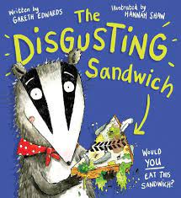 | 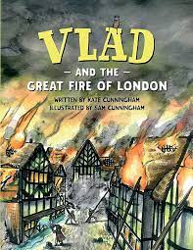 |  |  | 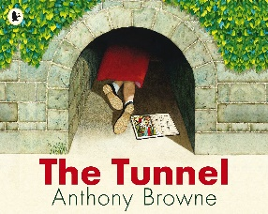
Little Red Riding Hood | The Disgusting Sandwich | Vlad and the Great Fire of London | Jim and the Beanstalk |  | The Tunnel
Outcome: A narrative | Outcome: A set of instructions (on how to make a sandwich). | Outcome: a narrative | Outcome: a narrative |  | Outcome: a personal narrative
Language Features:  Tense: Past  Person: 3rd  Formality: Formal  Text Features:  - Title  - Beginning (Once upon a time...)  - Middle  - (Happy) Ending  - Settings  - Characters (good and evil)  - Plot  - Magic/magical objects  - Action  - Dialogue  - Repeated Phrase  - Lesson learnt | Language Features:  Tense: Present  Person: 2nd  Formality: Formal  - Imperative verbs  - Time conjunctions/ adverbials  - Simple, clear sentences  - Adverbs  - Nouns and noun phrases  Text Features  - Title  - Time conjunctions/ adverbials  - List of equipment  - Clear, numbered steps | Text Features:  • Title and introduction (who, where, when)  • Chronological order  • Paragraphs around a theme or event  • Concluding sentence or reflection  Language Features:  Tense: Past  Person: 3rd  Formality: Formal  - Time adverbials (first, then, next)  - Emotive and descriptive language  - Expanded nouns  - Conjunctions to extend ideas | Text Features:  • Title and introduction (who, where, when)  • Chronological order  • Paragraphs around a theme or event  • Concluding sentence or reflection  Language Features:  Tense: Past  Person: 3rd  Formality: Formal  • Dialogue (with support)  • Time adverbials  • Descriptive language  • Simple sentence openers Time adverbials (first, then, next)  - Emotive and descriptive language  - Expanded nouns  - Conjunctions to extend ideas |  | Text Features:  Title  - Simple and clear: “The Tunnel”, “My Scary Adventure” or “Through the Tunnel”  Opening / orientation  - Who, where, when:  “One day after school, I found a dark tunnel behind the shed.”  First person viewpoint  - Use of I, my, we to make it personal:  “I felt scared but I wanted to know what was inside.”  Chronological sequence  - Clear order: finding the tunnel → going in → what was seen/heard → what happened next.  Simple ending  - Telling how it finished:  “At last, I saw the light and ran back home.”  “When I came out, I felt brave and proud.”  Focus on feelings and senses  - Describe what was seen, heard or felt:  “It was cold and dark. My heart was beating fast.”  Short, clear paragraphs  - Usually each new event or feeling.  Language Features:  Tense: Past  Person: 1st  Formality: Informal and personal, like talking to a friend.  Time connectives and sequencing words  - “First,” “Then,” “After that,” “Suddenly,” “Finally.”  Descriptive adjectives and noun phrases  - “Dark tunnel,” “cold stone walls,” “quiet, spooky place.”  Powerful verbs  - “Shivered,” “peeked,” “tiptoed,” “crept.”  Onomatopoeia  - “Drip,” “crunch,” “whoosh.”  Emotive language  - “I felt so scared,” “My tummy felt funny.”  Subordination (when, if, because, that, so that)  - Adds detail and explanation:  “I kept going because I wanted to see what was there.”  “When I heard a strange noise, I stopped.”  “I walked slowly so that I wouldn’t make a sound.”  Simple and compound sentences with and, but, so  - “It was dark and cold.”  - “I wanted to run but I felt too scared.”  Rhetorical question (if modelled)  - “What if something was waiting inside?”
Purpose: to report/inform |  |  |  |  | Poetry
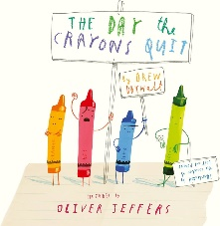
The Day the Crayons Quit
Outcome: a persuasive letter
Text Features:
• Letter format (greeting, body, sign-off)
• Clear viewpoint and purpose
• Paragraphs for key reasons

Language Features:
Tense: Present
Person: 3rd
Formality: Formal
• Emotive and persuasive language
• Rhetorical questions (with support)
• Conjunctions to link ideas

