Autumn 1: Marvellous Me
In Communication and Language, we will begin to listen to, and understand, one-step instructions. Alongside this, we will also start to explain things that are important to us and recall recent events. In addition to this, we will learn a new Makaton sign and nursery rhyme each week.
In Physical Development, we will explore how to move in a variety of different ways such as crawling, climbing, and jumping. We will also have lots of opportunities to develop our fine-motor skills, through sand and water play, using small tools, and zipping up our coats. | In Personal, Social and Emotional Development, we will start to become more aware of the familiar adults in our new environment, along with play alongside other children, and recognise the emotions we feel throughout the day.
In Maths, we will develop our awareness of numbers through counting by rote and learning a variety of new number rhymes. We will also explore shapes within our environment and sort objects into groups. | In Phonics, we will start to expand our awareness of various environmental sounds. We will tune into different sounds to identify where they come from.
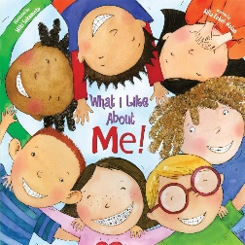
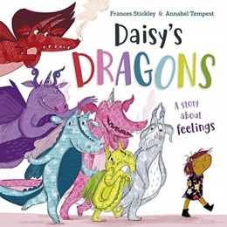
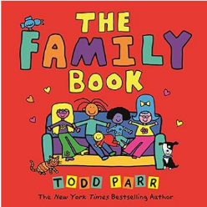

Autumn 2: Celebrations
In Communication and Language, we will start to interpret and answer who, where and what questions. We will also extend our vocabularies to reflect on experiences that are important to us.
We will continue to learn a new Makaton sign each week.
In Physical Development, we continue to explore using small tools such as, scissors and paintbrushes. We will develop our gross motor skills by climbing through and around different apparatus and throwing and catching a ball. | In Personal, Social and Emotional Development, we will continue to take part in our daily routine, along with understanding rules and why they are important. We will also start to understand how to take turns with others.
In Maths, we will continue to increase our understanding of numbers and count amounts up to 5. We will continue to explore different shapes and we will start to recognise repeating patterns. | In Phonics, we will start to recognise rhythm, rhyme, and alliteration. Along this, we will also learn how we can make a range of noises with our bodies, voices and musical instruments as well.
In Understanding the World, we will learn about the different celebrations around the world at this time of year.


