Resource 1 — Everyday Actions

1.Brush teeth twice a day for 2 minutes  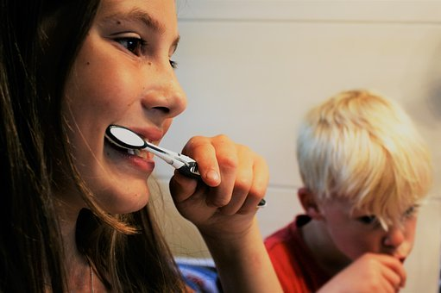 | 2. Drinking fizzy drinks  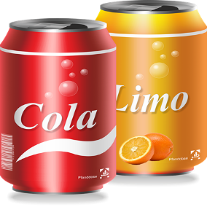 | 3.Visiting dentist regularly  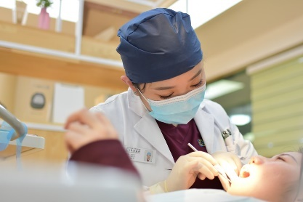
4.Smoking  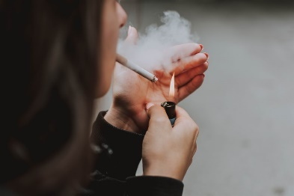 | 5. Fruit juice and smoothies   | 6. Spitting out toothpaste after brushing  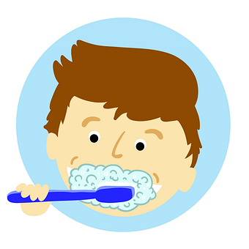
7. Forgetting to brush teeth  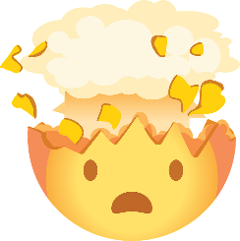 | 8. Flossing  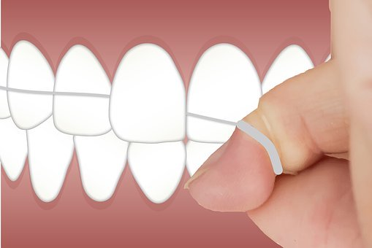 | 9. Eating foods lower in sugar  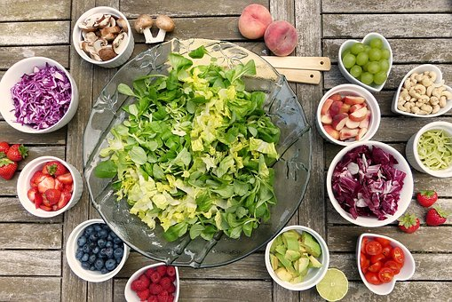

10. Eating foods high in sugar   | 11. Rinsing straightaway after brushing  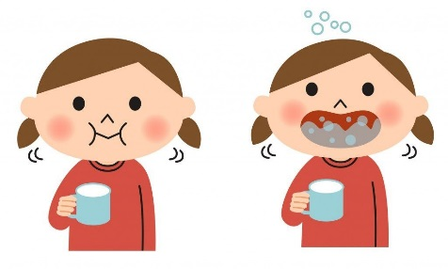 | 12. Chewing gum  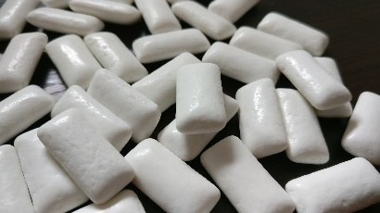
13. Drinking water  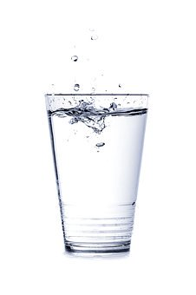 | 14. Not visiting the dentist  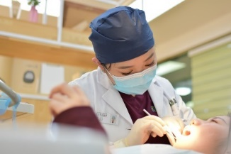 | 15. Mouthwash  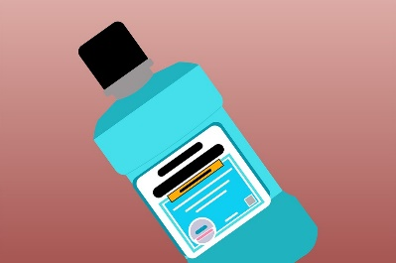

Resource 2 — Dental health facts

Brushing teeth twice a day for 2 minutes helps to remove plaque and stop tooth decay. | Cleaning between teeth by using floss helps to remove plaque, stops cavities and tooth decay. | Visiting the dentist regularly helps to keep teeth and gums healthy. The dentist will check for any problems, and remove plaque from teeth.
Eating foods lower in sugar such as fruit and vegetables and snacking on nuts, seeds and crackers are good for dental health. These foods help produce more saliva (spit) and stop plaque building up. | Drinking water washes away food and any sugars left behind on teeth, helping the enamel stay healthy and stop plaque from building up. | Spitting out toothpaste after brushing instead of rinsing with water will mean the fluoride stays on teeth for longer and helps to protect them.
Forgetting to brush teeth can cause plaque to build up and over time, could cause cavities. | Fizzy drinks such as cola and lemonade are high in sugar and can cause tooth decay. They also contain acid which can harm the enamel. | Smoking creates plaque on the teeth and can causes tooth decay or gum disease (gums become sore, swollen or infected).
Eating foods high in sugar such as sweets, chocolate, biscuits and cake can cause tooth decay. | Rinsing straightaway after brushing will wash away the important protective fluoride in toothpaste that should be left to stay on teeth. | Not visiting the dentist for a check-up could mean dental problems like tooth decay or cavities are not treated and could get worse.
Juices and smoothies can count as 1 of 5 a day but they have sugar in and so just having 1 small glass with a meal is best. | Chewing gum after eating can help produce more saliva (spit) and stop plaque building up. Brushing teeth and flossing are more important though, as they clean teeth thoroughly. | Using a mouthwash can help to stop tooth decay but brushing teeth and flossing is still needed for good dental health.

Resource 3 — Dental dilemmas
Sam brushes their teeth twice a day and drinks lots of water. Sam also love sweets and buys them in the shop every day after school. Recently, Sam has been having pain in the side of their mouth and now the gum is swollen too. Sam hasn’t told anyone because they are worried about getting into trouble with the dentist for eating sweets.
Lea has a 6 year old younger sister. She has begun to brush her teeth by herself before bed, but Lea has noticed that often she doesn’t do it, or only brushes for a few seconds. When Lea asks her sister why she isn’t brushing, she says that she keeps forgetting and that she doesn’t like the taste of the toothpaste.
Bailey follows the same routine every day. He brushes his teeth after waking up and just before bed, and flosses his teeth once a day. Lately, he has been feeling worried about his teeth — although Bailey now has most of his adult teeth, he has a few baby teeth that have not fallen out yet.
Jesse knows that too much food high in sugar can harm their teeth and so tries to eat snacks lower in sugar at break time, such as an apple or banana. Jesse’s friend Tom has been talking about other things they can do to keep their teeth healthy. Tom uses mouthwash in the morning and evening, and has chewing gum twice a day. Jesse is wondering whether to start doing those things too.
Yasmin doesn’t like eating fruit but loves drinking fruit juice. Someone in her class has told her that fruit juice damages teeth and now Yasmin is worried about drinking it.
Mohammed needs to have a tooth taken out and his Mum has told him they are going to the dentist next week. Mohammed is really worried because he is scared about going to the dentist and thinks he might cry when he gets there. Even though he knows the dentist will help him feel better, he is starting to get funny feelings in his tummy when he thinks about being there.

