St Matthew’s Church of England Primary School
Guide to completing your PE lessons from home: Just Dance

Before you start:

Change into appropriate sports clothing & trainers

Remove all jewellery & tie your hair back

Ensure the area you are working is safe and free from obstructions

Individual Dances

- Fifth Harmony: Worth It

- Footloose

- Shakira: Hips Don't Lie

- ABBA: Dancing Queen

- Britney Spears: Toxic

- Beyonce: Single Ladies

- Justin Bieber: Baby

- Elton John: I'm Still Standing

- Dua Lipa: New Rules

- Lil Nas X: Old Town Road

- Nicki Minaj: Starships

- Frozen: Into the Unknown

- Carly Rae Jepson: Call me Maybe

- Katy Perry: Firework
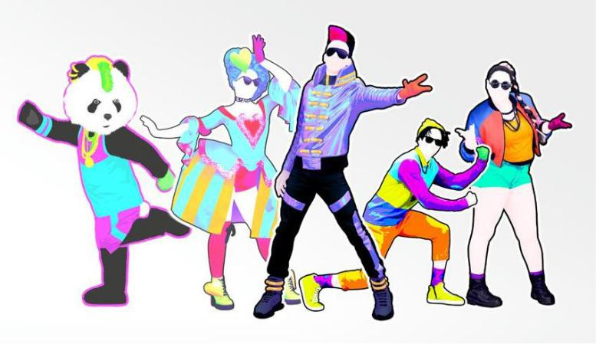

Paired Dances

- Pitbull: Timber

- Grease: You're the One that I Want

- Justin Bieber: Let me Love You

- Sia: Cheap Thrills

- Camila Cabello: Havana

- Chainsmokers: Closer

- PSY: Gangman Style

Group Dances

- One Direction: Kiss You

- One Direction: What Makes you Beautiful

- Katy Perry: Swish Swish

- ABBA: Mamma Mia

- Boney M: Rasputin

- Village People: YMCA

- Bruno Mars: Finesse

- Iggy Azalea: Fancy

- Eva Simpson: Policeman

- Will I Am: Scream and Shout

- Jason Derulo: Swalla

- Shakira: Waka Waka

- Ariana Grande: 7 Rings

- Silento: Watch me Whip

- Luis Fonsi: Despacito

- Taio Cruz: Dynamite

- Macarena

- Jason Derulo: Get Ugly

