Year 2 |  | Topic 1: Animals including Humans |  |  |  |  | Autumn Term
Statutory Requirements
- Notice that animals, including humans, have offspring which grow into adults.
- Find out about and describe the basic needs of animals, including humans, for survival (water, food and air).
- Describe the importance for humans of exercise, eating the right amounts of different types of food, and hygiene.
Prior Learning |  |  |  | Future Learning
Year 1  - Identify and name a variety of common animals that are carnivores, herbivores and omnivores.  - Identify, name, draw and label the basic parts of the human body and say which part of the body is associated with each sense. |  |  |  | Year 3  - Identify that animals, including humans, need the right types and amount of nutrition, and that they cannot make their own food; they get nutrition from what they eat.
Key Learning |  |  |  |  | Assessment
- Animals, including humans, have offspring which grow into adults.  - In humans and some animals, these offspring will be young, such as babies or kittens, that grow into adults. In other animals, such as chickens or insects, there may be eggs laid that hatch to young or other stages which then grow to adults.  - The young of some animals do not look like their parents e.g. tadpoles.  - All animals, including humans, have the basic needs of feeding, drinking and breathing that must be satisfied in order to survive.  - To grow into healthy adults, they also need the right amounts and types of food and exercise.  - Good hygiene is also important in preventing infections and illnesses. |  |  |  |  | Children can:  - Can describe how animals, including humans, have offspring which grow into adults, using the appropriate names for the stages  - Can state the basic needs of animals, including humans, for survival  - Can state the importance for humans of exercise, eating the right amounts of different types of food and hygiene  - Can name foods in each section of the Eatwell Guide
Key Vocabulary
offspring, reproduction, growth, baby, toddler, child, teenager, adult, old person, names of animals and their babies (e.g. chick/hen, kitten/cat, caterpillar/butterfly), survive, survival, water food, air, exercise, heartbeat, breathing, hygiene, germs, disease, food types (e.g. meat, fish, vegetables, bread, rice, pasta, dairy)
Common Misconceptions
Some children may think:
- an animal’s habitat is like its ‘home’
- all animals that live in the sea are fish
- respiration is breathing
- breathing is respiration.
Possible Scientific Enquiry Investigations
Comparative/Fair Testing | Research |  | Observation Over Time |  |  | Pattern-seeking |  | Identifying, Grouping and Classifying
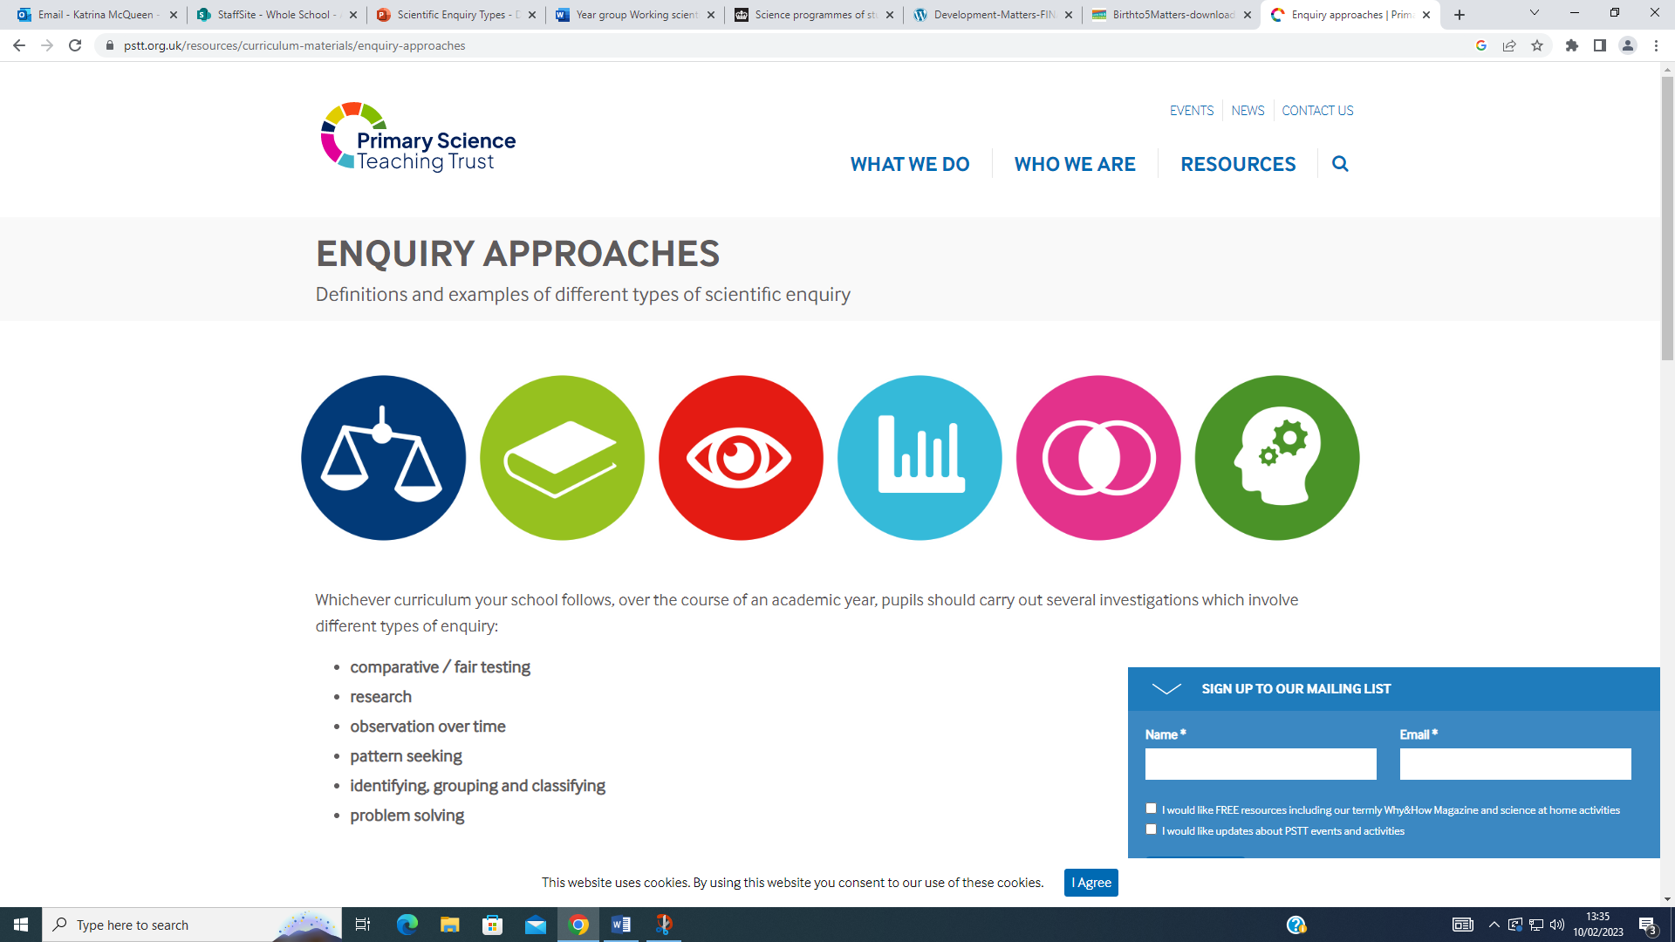
Investigate washing hands, using glitter gel.  Do bananas make us run faster? | Ask people questions and use secondary sources to find out about the life cycles of some  animals.  Ask questions of a parent about how they look after their baby and how pet owners look after their pet.  What food do you need in a healthy diet and why? |  | Observe animals growing over a period of time e.g. chicks, caterpillars, a baby.  How much food and drink do I have over a week? |  |  | Explore the effect of exercise on their bodies.  What age group of children wash their hands the most in a day? |  | Classify food in a range of ways, including using the Eatwell Guide.  Which offspring belongs to which animal?
Working Scientifically Success Criteria
Children can:
Describe, including using diagrams, the life cycle of some animals, including humans, and their growth to adults e.g. by creating a life cycle book for a younger child
Can measure/observe how animals, including humans, grow.
Show what they know about looking after a baby/animal by creating a parenting/pet owners’ guide
Explain how development and health might be affected by differing conditions and needs being met/not met

Year 2 | Topic 2: Living Things and Their Habitats |  | Spring Term
Statutory Requirements
- Explore and compare the differences between things that are living, dead, and things that have never been alive
- Identify that most living things live in habitats to which they are suited and describe how different habitats provide for the basic needs of different kinds of animals and plants, and how they depend on each other
- Identify and name a variety of plants and animals in their habitats, including micro-habitats
- Describe how animals obtain their food from plants and other animals, using the idea of a simple food chain, and identify and name different sources of food
Prior Learning |  | Future Learning
Year 1  - Identify and name a variety of common wild and garden plants, including deciduous and evergreen trees.  - Identify and describe the basic structure of a variety of common flowering plants, including trees.  - Identify and name a variety of common animals including fish, amphibians, reptiles, birds and mammals.  - Identify and name a variety of common animals that are carnivores, herbivores and omnivores.  - Describe and compare the structure of a variety of common animals (fish, amphibians, reptiles, birds and mammals, including pets).  - Observe changes across the four seasons. |  | Year 4:  - Recognise that living things can be grouped in a variety of ways.  - Explore and use classification keys to help group, identify and name a variety of living things in their local and wider environment.  - Recognise that environments can change and that this can sometimes pose dangers to living things.  - Construct and interpret a variety of food chains, identifying producers, predators and prey.

Key Learning |  |  | Assessment
- All objects are either living, dead or have never been alive. Living things are plants (including seeds) and animals. Dead things include dead animals and plants and parts of plants and animals that are no longer attached e.g. leaves and twigs, shells, fur, hair and feathers (This is a simplification, but appropriate for Year 2 children.) An object made of wood is classed as dead. Objects made of rock, metal and plastic have never been alive (again ignoring that plastics are made of fossil fuels).  - Animals and plants live in a habitat to which they are suited, which means that animals have suitable features that help them move and find food and plants have suitable features that help them to grow well. The habitat provides the basic needs of the animals and plants – shelter, food and water.  - Within a habitat there are different micro-habitats e.g. in a woodland – in the leaf litter, on the bark of trees, on the leaves. These micro-habitats have different conditions e.g. light or dark, damp or dry. These conditions affect which plants and animals live there.  - The plants and animals in a habitat depend on each other for food and shelter etc.  - The way that animals obtain their food from plants and other animals can be shown in a food chain. |  |  | Children can:  - Can find a range of items outside that are living, dead and never lived  - Can name a range of animals and plants that live in a habitat and micro-habitats that they have studied  - Can talk about how the features of these animals and plants make them suitable to the habitat  - Can talk about what the animals eat in a habitat and how the plants provide shelter for them  - Can construct a food chain that starts with a plant and has the arrows pointing in the correct direction
Key Vocabulary
living, dead, never been alive, suited, suitable, basic needs, food, food chain, shelter, move, feed, water, air, survive, survival, names of local habitats (e.g. pond, woodland etc.), names of micro-habitats (e.g. under logs, in bushes etc.), conditions, light, dark, shady, sunny, wet, damp, dry, hot, cold, names of living things in the habitats and microhabitats studied
Common Misconceptions
Some children may think:
- an animal’s habitat is like its ‘home’
- plants and seeds are not alive as they cannot be seen to move
- fire is living
- arrows in a food chain mean ‘eats’.
Possible Scientific Enquiry Investigations
Comparative/Fair Testing | Research | Observation Over Time |  | Pattern-seeking | Identifying, Grouping and Classifying
Explore the outside environment regularly to find objects that are living, dead and have never lived. | Create simple food chains for a familiar local habitat from first-hand observation and research. | Observe animals and plants carefully, drawing and labelling diagrams |  | Create simple food chains from information given e.g. in picture books (Gruffalo etc.). | Classify objects found in the local environment
Working Scientifically Success Criteria
Children can:
Can sort into living, dead and never lived
Can give key features that mean the animal or plant is suited to its micro-habitat
Using a food chain can explain what animals eat
Can explain in simple terms why an animal or plant is suited to a habitat e.g. the caterpillar cannot live under the soil like a worm as it needs fresh leaves to eat; the seaweed we found on the beach cannot live in our pond because it is not salty

Year 2 | Topic 3: Uses of Everyday Materials |  |  | Spring and Summer Term
Statutory Requirements
- Identify and compare the suitability of a variety of everyday materials, including wood, metal, plastic, glass, brick, rock, paper and cardboard for particular uses.
- Find out how the shapes of solid objects made from some materials can be changed by squashing, bending, twisting and stretching.
Prior Learning |  | Future Learning
Year 1  - Distinguish between an object and the material from which it is made.  - Identify and name a variety of everyday materials, including wood, plastic, glass, metal, water, and rock.  - Describe the simple physical properties of a variety of everyday materials.  - Compare and group together a variety of everyday materials on the basis of their simple physical properties. |  | Year 3:  - Compare and group together different kinds of rocks on the basis of their appearance and simple physical properties.  - Notice that some forces need contact between two objects, but magnetic forces can act at a distance.
Key Learning |  |  | Assessment
- All objects are made of one or more materials that are chosen specifically because they have suitable properties for the task. For example, a water bottle is made of plastic because it is transparent allowing you to see the drink inside and waterproof so that it holds the water.  - When choosing what to make an object from, the properties needed are compared with the properties of the possible materials, identified through simple tests and classifying activities.  - A material can be suitable for different purposes and an object can be made of different materials.  - Objects made of some materials can be changed in shape by bending, stretching, squashing and twisting. For example, clay can be shaped by squashing, stretching, rolling, pressing etc.  - This can be a property of the material or depend on how the material has been processed e.g. thickness. |  |  | Children can:  - Can name an object, say what material it is made from, identify its properties and make a link between the properties and a particular use  - Can label a picture or diagram of an object made from different materials  - For a given object can identify what properties a suitable material needs to have Whilst changing the shape of an object can describe the action used  - Can use the words flexible and/or stretchy to describe materials that can be changed in shape and stiff and/or rigid for those that cannot  - Can recognise that a material may come in different forms which have different properties
Key Vocabulary
Names of materials – wood, metal, plastic, glass, brick, rock, paper, cardboard
Properties of materials – as for Year 1 plus opaque, transparent and translucent, reflective, nonreflective, flexible, rigid
Shape, push/pushing, pull/pulling, twist/twisting, squash/squashing, bend/bending, stretch/stretching
Common Misconceptions
Some children may think:
- only fabrics are materials
- only building materials are materials
- only writing materials are materials
- the word rock describes an object rather than a material
- solid is another word for hard.

Possible Scientific Enquiry Investigations
Comparative/Fair Testing | Research | Observation Over Time | Pattern-seeking | Identifying, Grouping and Classifying
Test the properties of materials for particular uses e.g. compare the stretchiness of fabrics to select the most appropriate for Elastigirl’s costume, test materials for waterproofness to select the most appropriate for a rain hat  Which shapes make the strongest bridge?  Which material would be best for the roof of little pig’s house? | How have the materials we use changed over time?  How are plastics made? | How long do bubble bath bubbles last for?  Will a paper boat float forever? | Make suggestions about alternative materials for a purpose that are both suitable and unsuitable  Do magnetic materials always conduct electricity? | Classify materials.  Which materials are shiny and which are dull?
Working Scientifically Success Criteria
Children can:
Can sort materials using a range of properties?
Can explain using the key properties why a material is suitable or not suitable for a purpose
Can begin to choose an appropriate method for testing a material for a particular property
Can use their test evidence to select appropriate material for a purpose e.g. Which material is the best for a rain hat?

Year 2 | Topic 4: Plants |  | Summer Term
Statutory Requirements
- Observe and describe how seeds and bulbs grow into mature plants.
- Find out and describe how plants need water, light and a suitable temperature to grow and stay healthy.
Prior Learning |  | Future Learning
Year 1  - Identify and name a variety of common wild and garden plants, including deciduous and evergreen trees.  - Identify and describe the basic structure of a variety of common flowering plants, including trees. |  | Year 3:  - Identify and describe the functions of different parts of flowering plants: roots, stem/trunk, leaves and flowers.  - Explore the requirements of plants for life and growth (air, light, water, nutrients from soil, and room to grow) and how they vary from plant to plant.  - Investigate the way in which water is transported within plants.  - Explore the part that flowers play in the life cycle of flowering plants, including pollination, seed formation and seed dispersal.
Key Learning |  |  |  | Assessment
- Plants may grow from either seeds or bulbs. These then germinate and grow into seedlings which then continue to grow into mature plants.  - These mature plants may have flowers which then develop into seeds, berries, fruits etc.  - Seeds and bulbs need to be planted outside at particular times of year and they will germinate and grow at different rates.  - Some plants are better suited to growing in full sun and some grow better in partial or full shade.  - Plants also need different amounts of water and space to grow well and stay healthy. |  |  |  | Children can:  - Can describe how plants that they have grown from seeds and bulbs have developed over time  - Can identify plants that grew well in different conditions
Key Vocabulary
light, shade, Sun, warm, cool, water, space, grow, healthy, bulb, germinate, shoot, seedling
Common Misconceptions
Some children may think:
- plants are not alive as they cannot be seen to move , seeds are not alive
- all plants start out as seeds
- seeds and bulbs need sunlight to germinate.

Possible Scientific Enquiry Investigations
Comparative/Fair Testing | Research | Observation Over Time | Pattern-seeking | Identifying, Grouping and Classifying
Make comparisons between plants as they grow.  Do seeds grow quicker inside or outside?  Do different plants prefer to live in different places? | Research and plan when and how to plant a range of seeds and bulbs.  How does a cactus survive in the desert with water? | Make close observations of seeds and bulbs  Make close observations and measurements of their plants growing from seeds and bulbs  What happens to my bean after I have planted it?  How long do cut flowers last? | Look after the plants as they grow – weeding, thinning, watering etc.  Do bigger seeds grow into bigger plants? | Classify seeds and bulbs  How can we identify the trees that we observed on our hunt?
Working Scientifically Success Criteria
Children can:
Can spot similarities and difference between bulbs and seeds
Can nurture seeds and bulbs into mature plants identifying the different requirements of different plants

